CLASSROOM AUDIT TOOL
SELF-WORK

Use the questions and example responses below as a guide to reflect on your own gender identity, expression and journey (questions 1-6) as well as your beliefs, expectations, and understandings about gender more generally (questions 7-18). There are many ways to do this! Here are a few we recommend:
- Make a date with a friend and take turns asking each other these questions. Give each other time to talk without interrupting. (Some people like to do this while taking a walk, or sitting at a beach or park; others like to meet over food or drinks. Make a date that works for you!)
- Use the questions as drawing/art prompts. Try an artistic medium in which you're a beginner! Focus on expressing your feelings surrounding the memories rather than creating "finished" products.
- Make up a song or a little jingle with your responses. If appropriate, share them with the kids you care for!
- Make some time for yourself to just write in your journal.
You’re welcome to use the text areas to type your reflections. Pressing ‘share with us’ means that you are giving us permission to use your examples in future versions of the audit tool, in workshops, etc.

Note: If you think your answer to any self-work question is "this doesn't apply to me," we challenge you to dig a little deeper!

1. What do I love about my gender?

Example
"I love wearing my sun dress! It's so comfortable and practical for moving around in while keeping cool when it's hot out, and also glamorous. I also love how I've been socialized to express my feelings and nurture others. I think those skills are super important in building a better world."
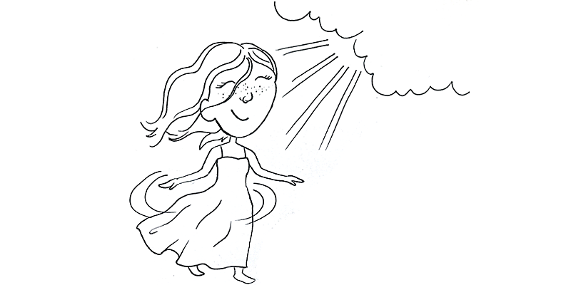

2. When was a time I felt really affirmed or a sense of belonging in my gender?

Example
"As a nerdy kid, I always felt out of place--not Black enough, not man enough. I had an English teacher in tenth grade who I really connected with. He wore tweed jackets, sometimes a three-piece suit, and he rocked an afro. He was straight, but talked to us honestly about all kinds of sexuality. That was the first time I felt like I really had a model of Black masculinity that fit with who I was."
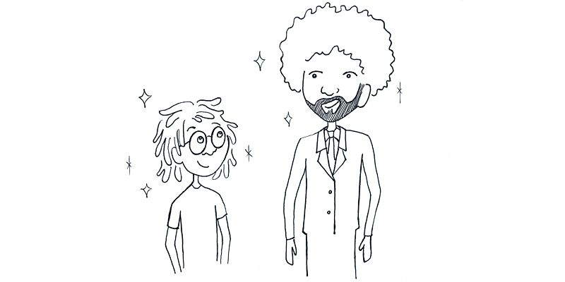

3. What are some obstacles I've faced in trying to authentically express and represent myself?

Example
"When I came out as a lesbian in the ‘90s, there was huge pressure to cut my hair short and wear flannel shirts and have that androgynous gender look. It took me a long time to realize I can be femme and queer at the same time!"

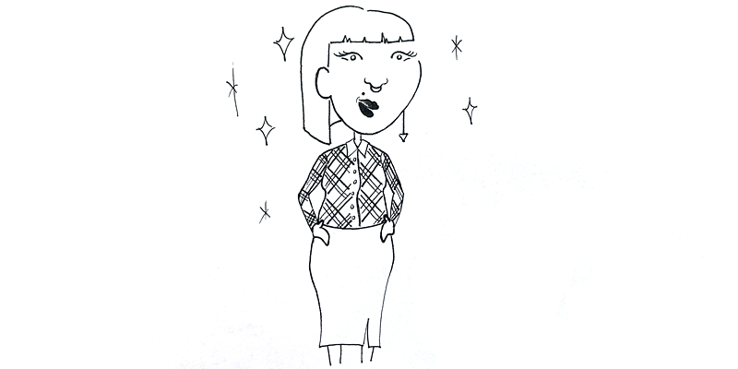

4. What are some ways that others have forced me to fit into their beliefs and expectations about gender?

Example
"When I was a young, my mom wouldn't let me play softball or ride a skateboard because she thought it was too dangerous for a girl."
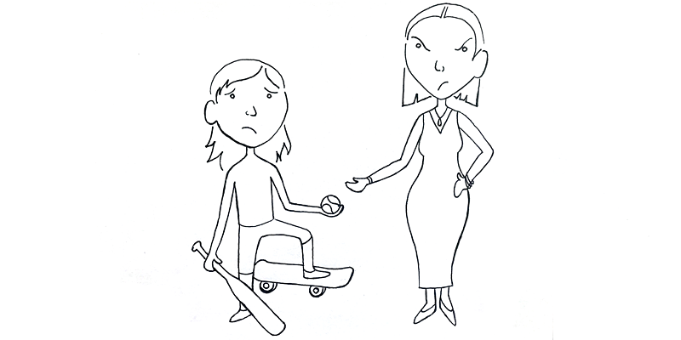

5. What are some ways society's gender norms^ have limited me or hurt me?

Example
"I hate wearing heels every day and spending all that time on makeup. But at my last job, that was the culture. I wouldn't have been taken seriously as a woman without it."

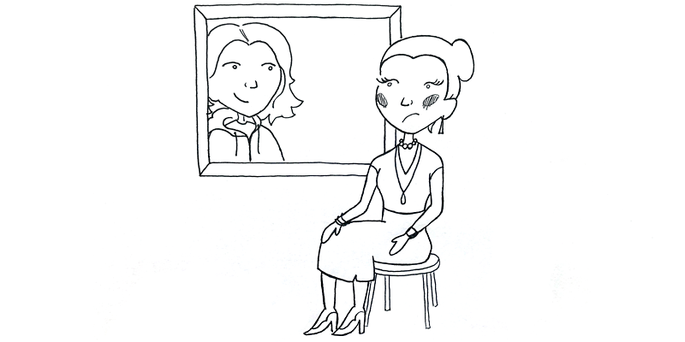

^Gender norms are the often unspoken social rules that dictate how we should behave and express ourselves based on our gender. Gender norms vary across and within cultures. For example, in the US there is an old expectation for white women of high social standing to be soft-spoken and graceful, while white working class women are expected to be brash and tough.

6. Has there been a time when I felt a disconnect between how someone sees my gender and who I know myself to be?

Example
"As a kid, I identified as a tom boy. I remember dressing up for a wedding and an adult commenting, 'what a perfect little flower girl.' I still remember how mad that made me!"
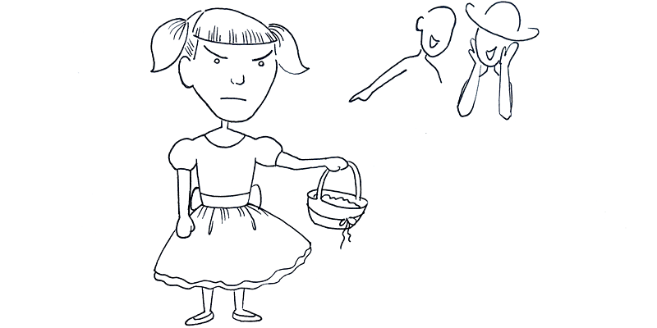

7. What are some ways I've forced others to fit into my beliefs and expectations about gender throughout my life?

Example
"I gave my little brother a really hard time about his paper doll collection."
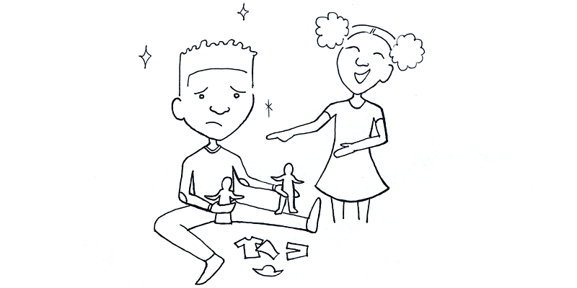

8. What are some conscious and subconscious reactions I have when my expectations about gender are disrupted?

Example
"When I can't tell what gender someone is, it makes me anxious. I don't know how to address them and it's easier to avoid them completely."

9. Which of society's expectations about gender have always felt easy and natural for me to go along with without questioning?

Example
"As a male teacher, I guess I'm expected to lead more of the outside play and the rough and tumble play. But I've never thought about it this way, because I just naturally like those things! Now that I think about it, I probably shouldn't be calling my female coworkers to help every time there's an injury."

10. Am I willing to lean into and sit with feelings of discomfort when my beliefs and expectations about gender are disrupted?

Example
"I realize that I have struggled a bit with Bella not wanting to be referred to as a boy OR a girl. I get stuck on the pronouns. Binary language is really frustrating!"
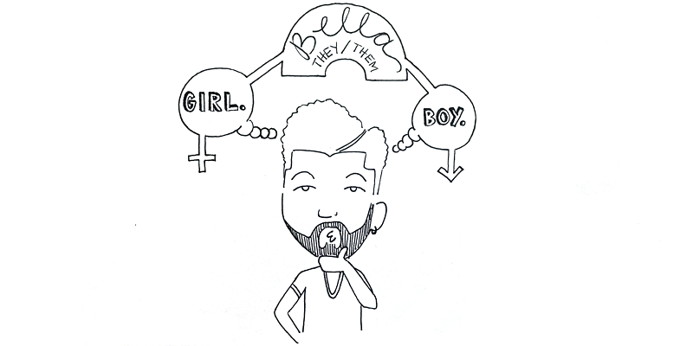

11. Am I willing to approach those who challenge my beliefs, values and concepts of gender with curiosity rather than judgement?

Example
"I used to laugh at men in dresses as joke. Now I see it can be hurtful to children who are assigned male and are attracted to dresses to treat that as something to laugh at."
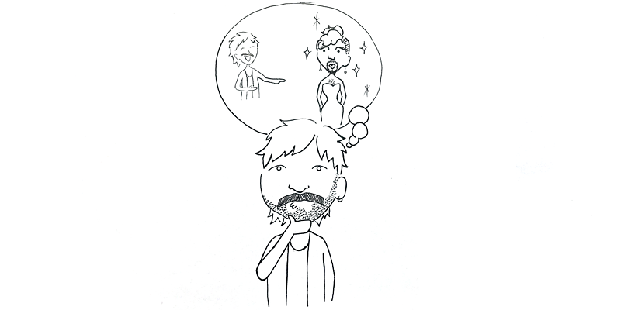

12. When I listen, am I open to being affected or changed?

Example
"What you just said doesn't fit in my worldview of how I understand gender. And, I know that we've had very different experiences. Can you tell me more about where you're coming from?"
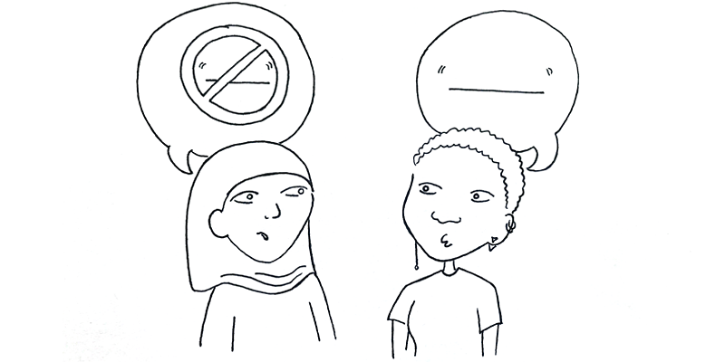
13. Do I believe each child in my care is the expert on their own gender, and am I ready to follow their lead and to support them in their journey?

Example
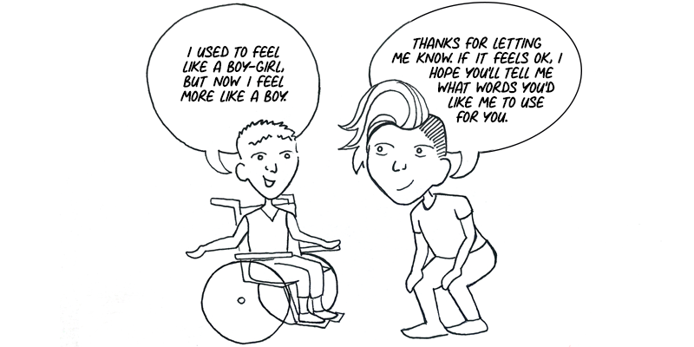

14. What are some aspects of my gender expression, behavior, identity and journey that break gender norms? How can I highlight these in my program as strengths?

Example
"I want to show the children I work with that nobody fits within all the gender norms and expectations, but I don't want it to be forced or to come off as a joke. I think I'll tell them about the experiences I had as a boy who always loved to dance and act. I was bullied for it as a child, but I'm proud of who I am and the things I love. I fit a lot of the norms of adult malehood, but I still love to dance and put on costumes for dramatic play!"
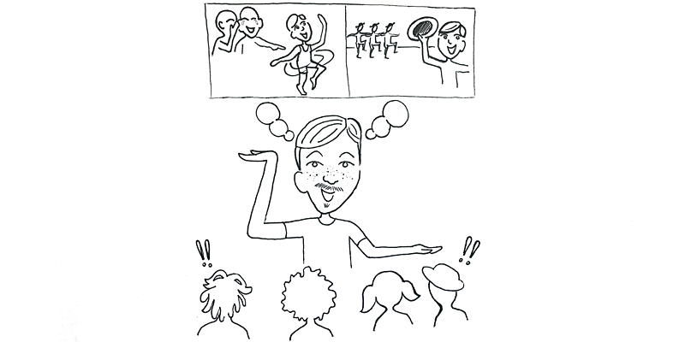

Infant/toddler example
”Pulling out my tools as a female provider, I can see the toddlers look at me and have gears turn. And when I get in the mud and get dirty, I'm modeling an expression of adult femininity they may not see anywhere else.”

15. How do I and my students benefit from understanding gender diversity, confronting stereotypes and knowing ourselves? How does this impact cisgender as well as transgender and gender expansive students?

Example
"Ever since I started thinking about how gender stereotypes influenced my identity development, I've been getting more adventurous with what I wear and how I let myself move in front of other people. It feels like a breath of fresh air!"

16. Who can I ask to be an accountability partner to support me in this work, if I don't already have one? (It could be someone I work with or someone I check in with on a regular basis.)

Example
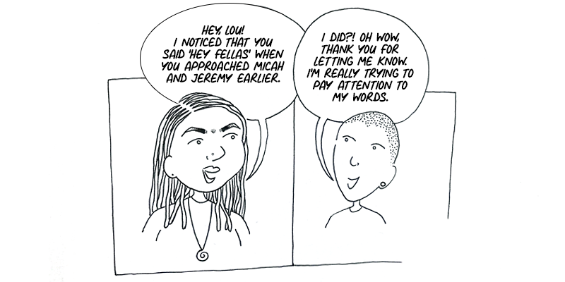

17. How will I continue my learning about gender, including seeking out a diversity of first-person perspectives about gender?

Example
"I've been looking for more books about transgender experiences for my own ongoing learning, but a lot of them seem to be written by folks who are not transgender themselves. I am going to do some research this weekend to find some that are actually written by trans folks!"

18. What are some language habits I'll work on changing (e.g. using people's preferred pronouns, referring to groups of people in gender-inclusive ways, replacing gendered terms like "fireman" with inclusive terms like "firefighter," etc)? Acknowledging that it is very difficult to change language patterns I've used my whole life, and knowing that it's for the health of the children in my care, how will I practice these changes?

Example
